**Strategy about future**

**Material and Human resource**

As it is seen page (relevant factors technology) charging station hardware cost and labor costs have the biggest shares of charging stations. While the charging station technology advancing, other than electrician labor costs increase. This shows that advancing technology in charging stations requires highly skilled human resources that is not available enough for the market at present. Human Resource departments of charging station companies should focus to solve this problem now for the future. Hardware costs of charging stations in the future will down with developments in manufacturing and technology. Moreover, charging stations should be easy to setup and use. But it is also deeply related with the laws and regulations because usage of high level electricity related products covered by laws. Easy and more secure ways to set up charging stations can also decrease the costs labor.

**EVs battery**

Future developments in EVs battery will always play a key role in both EVs and EVs charger industry. Not just cost issue but also technological innovations are also bounded with charger technology and industry. There are many important specifics about battery such as cost parity, range parity, charging, swapping, refilling, lifespan and safety. In order to have competitive advantage in EVs charging industry, it is vital to be updated and ready for innovations in EV battery technologies.

**Charging speed**

As it is mentioned before charging speed is the competitive factor in the market. To increase the charging speed, developments and innovations in the EVs battery must be followed closely. Although, DC fast chargers at present are fast enough, those still has very high costs. Decreasing cost of fast DC chargers with developments in manufacturing these systems will provide big advantage for EVs and EVs charging station market in the future.

**Home battery**

***[EVs chargers will not just connect cars to grid in order to buy and sell electricity but also communicate and cooperate with home batteries to manage energy supply and demand of a house as being player of energy market.]***

Tesla Energy developed an innovative product as home battery that is called Powerwall. “*Home battery that charges using electricity generated from solar panels, or when utility rates are low, and powers your home in the evening. Powerwall offers independence from the utility grid and the security of an emergency backup. Without a home battery, excess solar energy is often sold to the power company and purchased back in the evening. This mismatch adds demand on power plants and increases carbon emissions. Powerwall bridges this gap between renewable energy supply and demand by making your home’s 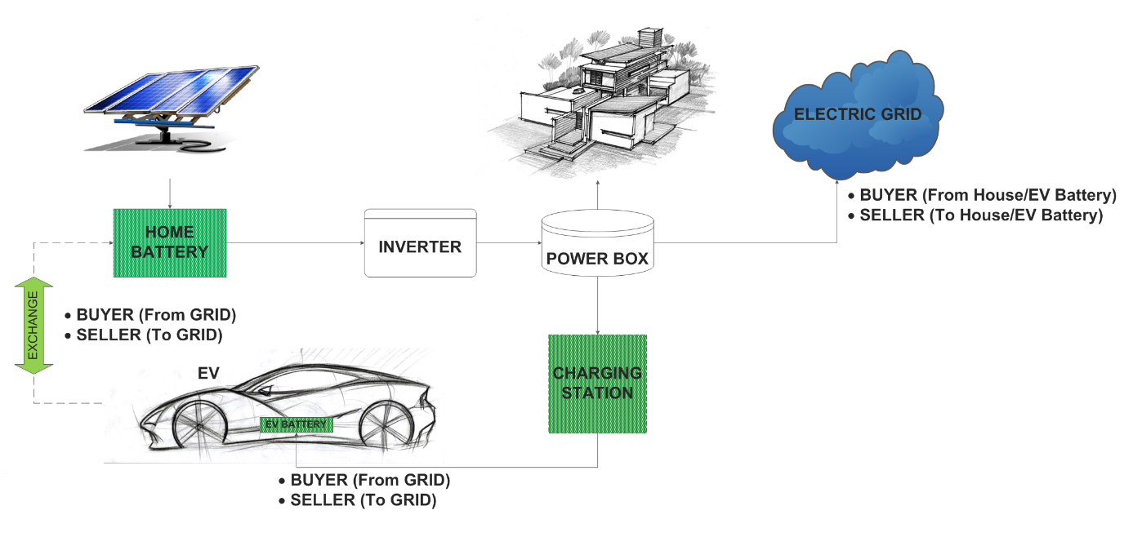solar energy available to you when you need it.”[1]*

This innovative factor will have great impact on our understanding about energy market and grid systems most probably. After this kind of home batteries become common, EVs charger will not be just a bridge between grid and EVs. There will be three actors in the energy system as Smart Grid, home battery and EVs. All will be simply energy buyer and seller. This innovation will become real product in summer of 2015 in U.S. market. EVs charging manufacturers must consider possible effects of this new technology on EVs charging systems.

**Wireless Charging**

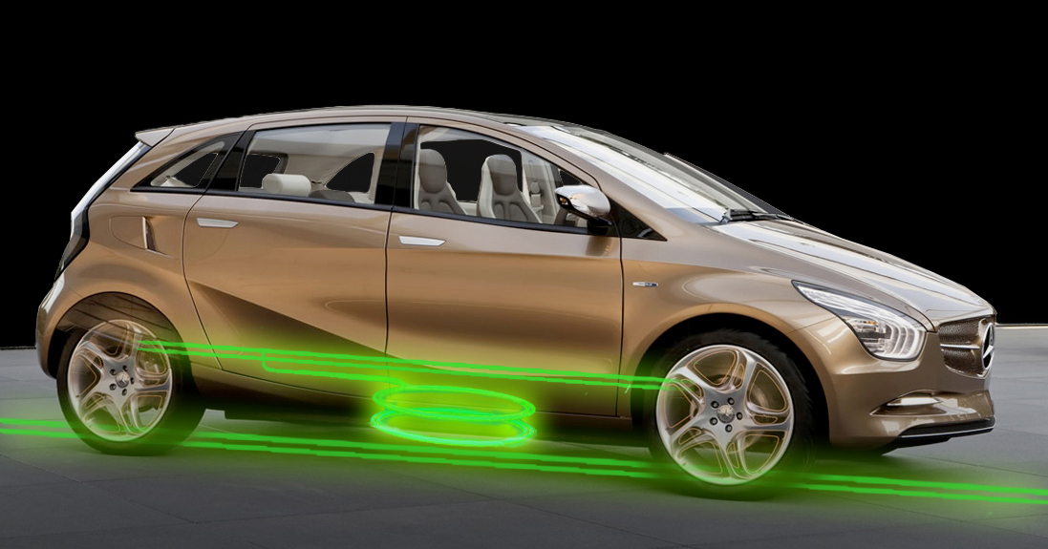

Wireless charging already in the market and new companies such as BMW, start to produce new products for this new technology. But most of these products are stationary wireless charging station that is tried to be standardized by a working group established by IEEE, in which academic experts, industry experts and government representatives. However, “*The main advantage of wireless charging while the vehicle is in motion is the automation of the charging process and the resulting additional range –thus the use of an internal combustion engine as a ”range extender“ and the use of larger and thus heavier batteries are not necessary. The larger challenges are in the standardization of the energy transfer frequencies, the acceptable limits of electromagnetic field strengths to minimize health risks, the geometrical parameters of the positioning of the coils (package-relevant), and the cooling technologies for higher energy transfer power levels.   It should also be noted that rules for infrastructure financing and technical standardization should be developed prior to commercialization.”* By Staff Editor of IEEE Transportation and Electrification Community and Joachim G. Taiber

**Pricing**

There are different kind of payments around the globe such as payment by the hour, the kilowatt-hour, per session fee and monthly or annual subscription fee. And bunch of charging stations are free. House charging is always cheaper than other stations that charge fee. Some of the stations are independently owned and prices set by the owner.[2] “*In California and many other states the most long term economical way to charge your electric vehicle is to install an electric vehicle meter dedicated to charging your electric car. This can be a complex and expensive project to undertake that depending upon your existing infrastructure, may take years in savings to see a return*“[3]

Note: Photos in the folder can be used if needed. I could not find enough resource and data to proof strategic plan of applying blockchain technology to payment system.

**REFERENCES**

Teslamotors.com, (2015). *Powerwall | Tesla Home Battery*. [online] Available at: http://www.teslamotors.com/powerwall [Accessed 5 Jun. 2015].

Evelectricity.com, (2015). *Evelectricity :: Electric Vehicle Charging Costs*. [online] Available at: http://www.evelectricity.com/ev-charging/electric-vehicle-charging-costs [Accessed 5 Jun. 2015].

Teslamotors.com, (2015). *Powerwall | Tesla Home Battery*. [online] Available at: http://www.teslamotors.com/powerwall [Accessed 5 Jun. 2015].

Electricvehicle.ieee.org, (2015). *Wirelessly Charge Electric Vehicles by Induction While Driving - IEEE Transportation Electrification Initiative Web Portal*. [online] Available at: http://electricvehicle.ieee.org/2014/02/04/wirelessly-charge-electric-vehicles-by-induction-while-driving/ [Accessed 5 Jun. 2015].

Szondy, D. (2015). *BMW developing wireless inductive charging system for electric vehicles*. [online] Gizmag.com. Available at: http://www.gizmag.com/bmw-induction-charging/32863/ [Accessed 5 Jun. 2015].

Plugless Power, (2015). *Wireless Electric Vehicle Charging - Plugless Power by Evatran*. [online] Available at: https://pluglesspower.com/ [Accessed 5 Jun. 2015].

1. Teslamotors.com, (2015)
2. Evelectricity.com, (2015)
3. Evelectricity.com, (2015)